Programing Fundamental

1st Assignment

Session: 1E

Name:

Sabir Hussain

Roll no:

BCSM-f19-262

Pro: Hafiz Muhammad Zahid

1. Write a program that inputs temperature from the user in Fahrenheit and converts

it into Celsius degree using formula 5/9(F – 32).

**Program:**

#include<iostream>

#include<conio.h>

using namespace std;

int main ()

{

float f, c;

cout<<"Enter temperature in Fahrenheit=";

cin>>f;

c= (5.0/9.0) *(f-32);

cout<<"Fahrenheit temperature in Celsius degree"<<endl;

cout<<"Celsius degree="<<c;

getch ();

return 0; }

**Output console:2**

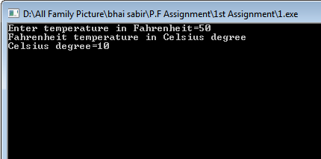

**Output console:1**

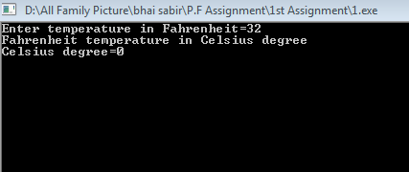

2. Write a program that inputs miles from the user and converts miles into kilometers.

One mile is equal to 1.609 kilometer.

**Program:**

**#include<iostream>**

**#include<conio.h>**

**using namespace std;**

**int main ()**

**{**

**float mile, kilo;**

**cout<<"Enter Distance in miles=";**

**cin>>mile;**

**kilo=mile*1.609;**

**cout<<"Conversion of miles into kilometer "<<endl<<endl;**

**cout<<kilo<<" Km";**

**getch ();**

**return 0;**

**}**

**Output console:1**

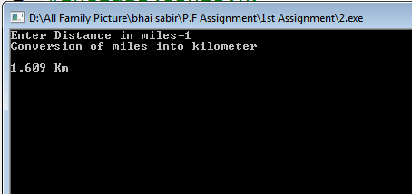

**Output console:2**

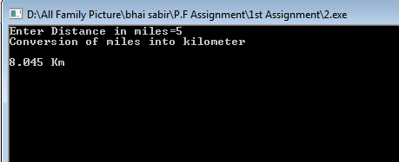

3. Write a program that inputs 4 numbers and calculates the sum, average an Product of all the numbers.

**Program:**

**#include<iostream>**

**Output console:** 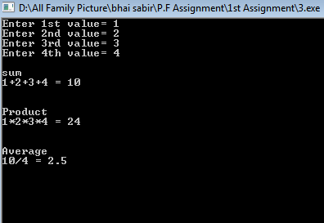

**#include<conio.h>**

**using namespace std;**

**int main ()**

**{**

**float n1, n2, n3, n4, sum, avg, pro;**

**cout<<"Enter 1st value= ";**

**cin>>n1;**

**cout<<"Enter 2nd value= ";**

**cin>>n2;**

**cout<<"Enter 3rd value= ";**

**cin>>n3;**

**cout<<"Enter 4th value= ";**

**cin>>n4;**

**cout<<endl<<"sum"<<endl;**

**sum=n1+n2+n3+n4;**

**cout<<n1<<"+"<<n2<<"+"<<n3<<"+"<<n4<<" = "<<sum<<endl<<endl;**

**cout<<endl<<"Product"<<endl;**

**pro=n1*n2*n3*n4;**

**cout<<n1<<"*"<<n2<<"*"<<n3<<"*"<<n4<<" = "<<pro<<endl<<endl;**

**cout<<endl<<"Average"<<endl;**

**avg=sum/4;**

**cout<<sum<<"/"<<"4"<<" = "<<avg<<endl<<endl;**

**getch ();**

**return 0;**

**}**

**4. Write a program that displays the following output:**

**Number Square Cube**

**1 1 1**

**2 4 8**

**3 9 27**

**4 16 64**

**5 25 125**

**Program:**

**#include<iostream>**

**#include<conio.h>**

**using namespace std;**

**int main ()**

**{**

**int n=1;**

**cout<<"Number\tSquare\tCube"<<endl<<endl;**

**start:**

**{**

**cout<<n<<"\t"<<n*n<<"\t"<<n*n*n<<endl<<endl;**

**n++;**

**Output console:**

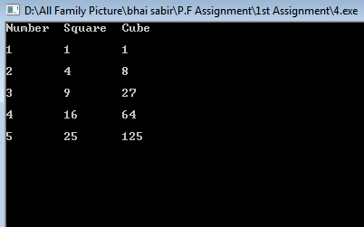

**}**

**if(n<=5)**

**{**

**goto start;**

**}**

**getch ();**

**return 0;**

**}**

**5. Write a program to find out the area of triangle when three sides a, b and c of the triangle are given. Use appropriate statements to input the values a, b and c from the keyboard. Formula for the area of triangle is**

**S=(a+b+c)/2**

**Area of Triangle= $√s(s-a)(s-b)(s-c)$**

**Program:**

#include<iostream>

#include<conio.h>

#include<math.h>

using namespace std;

int main ()

{

float a, b, c, s, result;

cout<<"Enter the value of a = ";

cin>>a;

cout<<"Enter the value of b = ";

cin>>b;

cout<<"Enter the value of c = ";

cin>>c;

s=(a+b+c)/2;

result=sqrt(s*(s-a) *(s-b) *(s-c));

cout<<endl<<endl<<"The area of triangle = "<<result;

getch ();

**Output console:**

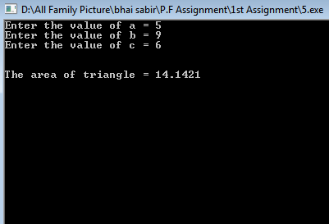

return 0;

}

6. Write a program that calculates the electricity bill. The rates of electricity per unit are as follows:

* If the units consumed are <= 300, then the cost is Rs. 2 per unit.
* If the units consumed are >300 and <=500, then the cost is Rs. 5 per unit.
* If the units consumed exceed 500 then the cost per unit is Rs. 7

A line rent Rs. 150 is also added to the total bill and a surcharge of 5% extra if the bill exceeds Rs. 2000. Calculate the total bill with all the conditions given above.

**Program:**

**#include<iostream>**

**#include<conio.h>**

**using namespace std;**

**int main ()**

**{**

**float u, bill, Total;**

**again:**

**cout<<"Enter units consumed = ";**

**cin>>u;**

**if(u>0&&u<= 300)**

**{**

**cout<<endl<<endl<<"The cost is Rs. 2 per unit"<<endl;**

**bill=2*u;**

**}**

**else if(u>300&&u<=500)**

**{**

**cout<<endl<<endl<<"The cost is Rs. 5 per unit"<<endl;**

**bill=5*u;**

**}**

**else if(u>500)**

**{**

**cout<<endl<<endl<<"The cost is Rs. 7 per unit"<<endl;**

**bill=7*u;**

**}**

**else**

**{**

**cout<<endl<<"You enter invalid Units consumed value";**

**cout<<endl<<"Again Enter units consumed"<<endl;**

**goto again;**

**}**

**Total=150+bill;**

**if (Total>2000)**

**{**

**Total=Total+(5.0/100.0) *Total;**

**}**

**cout<<endl<<endl<<"Total Electricity Bill = Rs."<<Total;**

**getch ();**

**return 0; }**

**Output console:2(<=300)**

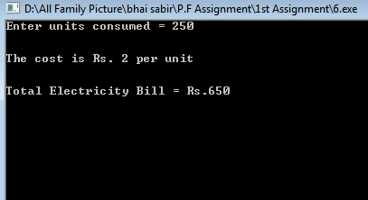

**Output console:1(-n & 0)**

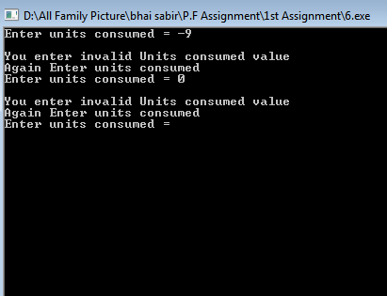

**Output console:4(>500)**

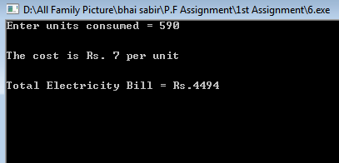

**Output console:3(<=500)**

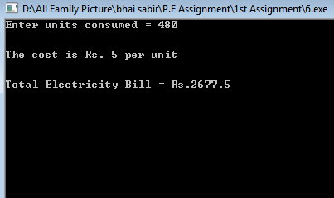

**7. Write a program that inputs three numbers and displays whether all the numbers are equal or not by using nested if condition.**

**Program:**

**#include<iostream>**

**#include<conio.h>**

**using namespace std;**

**int main ()**

**Output console:1**

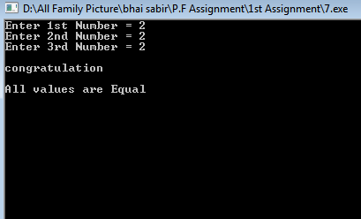

**{**

**float n1, n2, n3;**

**cout<<"Enter 1st Number = ";**

**cin>>n1;**

**cout<<"Enter 2nd Number = ";**

**cin>>n2;**

**cout<<"Enter 3rd Number = ";**

**cin>>n3;**

**if(n1==n2)**

**{**

**if(n2==n3)**

**{**

**cout<<endl<<"congratulation";**

**cout<<endl<<endl<<"All values are Equal";**

**}**

**else**

**{**

**cout<<endl<<"Sorry";**

**cout<<endl<<endl<<"values are not Equal";**

**}**

**}**

**else**

**{**

**cout<<endl<<"Sorry";**

**cout<<endl<<endl<<"values are not Equal";**

**}**

**getch ();**

**return 0;**

**}**

**Output console:3**

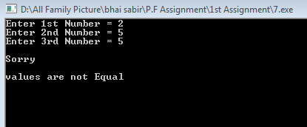

**Output console:2**

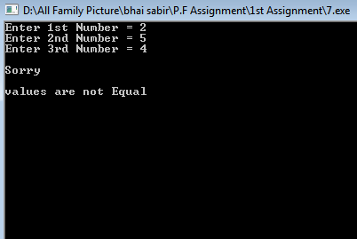

**8.** Write a program that inputs a value and type of conversion. The program should then display the output after conversion. The program should include following conversions:

* 1 cm = .394 inches
* 1 liter = .264 gallons
* 1 kilometer = .622 miles
* 1 kilogram = 2.2 pounds

**Make sure that the program accepts only valid choices for the type of conversion**.

**Program:**

**#include<iostream>**

**#include<conio.h>**

**using namespace std;**

**int main ()**

**{**

**float n1, result;**

**int choice;**

**cout<<"Enter any Value = ";**

**cin>>n1;**

**cout<<endl<<endl<<"1. Convert cm(centimetter) into inches"<<endl;**

**cout<<endl<<endl<<"2. Convert liter into gallons"<<endl;**

**cout<<endl<<endl<<"3. Convert kilometer into miles"<<endl;**

**cout<<endl<<endl<<"4. Convert kilogram into pounds"<<endl;**

**cout<<"Enter Your Choice = ";**

**cin>>choice;**

**switch(choice)**

**{**

**case 1:**

**{**

**cout<<endl<<endl<<"Conversion of cm(centimetter) into inches"<<endl;**

**result=n1*0.394;**

**cout<<n1<<" cm = "<<result<<" inches";**

**break;**

**}**

**case 2:**

**{**

**cout<<endl<<endl<<"Conversion of liter into gallons"<<endl;**

**result=n1*0.264;**

**cout<<n1<<" Liter = "<<result<<" gallons";**

**break;**

**}**

**case 3:**

**{**

**cout<<endl<<endl<<"Conversion of kilometer into miles"<<endl;**

**result=n1*0.622;**

**cout<<n1<<" Kilometer = "<<result<<" miles";**

**break;**

**}**

**case 4:**

**{**

**cout<<endl<<endl<<"Conversion of kilogram into pounds"<<endl;**

**result=n1*2.2;**

**cout<<n1<<" kilogram = "<<result<<" pounds";**

**break;**

**}**

**default:**

**{**

**cout<<endl<<endl<<"You enter Invalid choice";**

**}**

**}**

**getch ();**

**return 0;}**

**Output console:2**

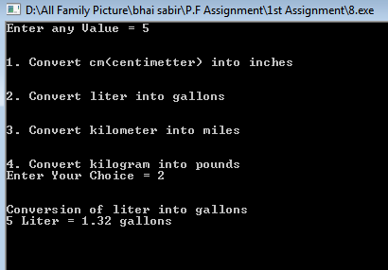

**Output console:1**

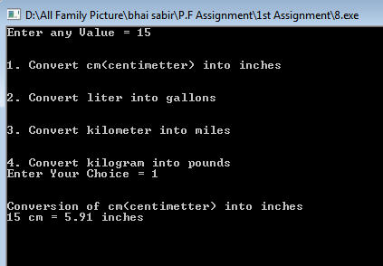

**Output console:5**

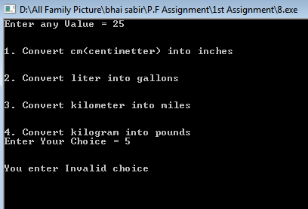

**Output console:4**

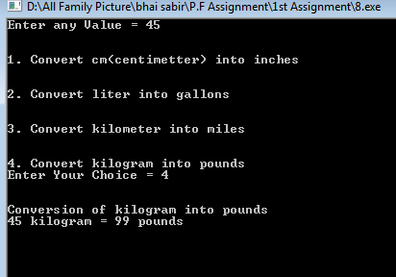

**Output console:3**

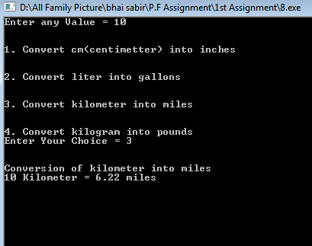

9. Write a program that allows the user to enter any character through the keyboard and determines whether it is a capital letter, small case letter, a digit number or a special symbol.

**Hint: >=‘A’ and <=‘Z’. >= ‘a’ and <= ‘z’ and for digit letter, >=‘0’ and <=‘9’. If a letter/character doesn’t satisfy above three conditions it means character is a symbol.**

**Program:**

**#include<iostream>**

**#include<conio.h>**

**using namespace std;**

**int main ()**

**{**

**char c;**

**cout<<"Enter any Charactor = ";**

**cin>>c;**

**if(c>='A'&&c<='Z')**

**{**

**cout<<endl<<endl<<c<<" is a Capital Letter";**

**}**

**else if(c>='a'&&c<='z')**

**{**

**cout<<endl<<endl<<c<<" is a Small Letter";**

**}**

**else if(c>='0' && c<='9')**

**{**

**cout<<endl<<endl<<c<<" is a Digit Number";**

**}**

**else**

**{**

**cout<<endl<<endl<<c<<" is a Special Symbol.";**

**}**

**getch ();**

**return 0;**

**}**

**Output console:1**

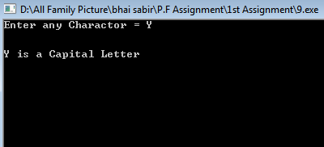

**Output console:2**

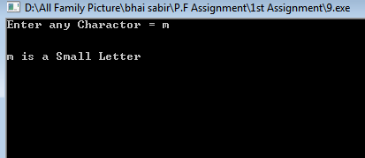

**Output console:4**

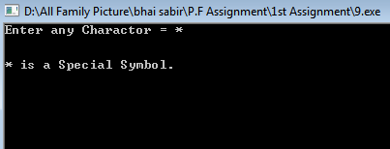

**Output console:3**

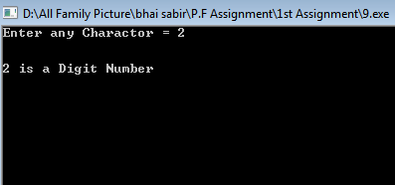

**10. Write a program that gets the number and a letter as input. If the letter entered by user is ‘f’, the program should treat the number entered as temperature in degrees Fahrenheit and convert it convert it to the temperature in degree Celsius and print a suitable message. If the letter is ‘c’, the program should consider the number as Celsius temperature and convert it to Fahrenheit temperature and print a suitable message. The program should display error message and then exit if the user enters any other letter.**

**Program:**

**#include<iostream>**

**#include<conio.h>**

**using namespace std;**

**int main ()**

**{**

**float n1, temp;**

**char choice;**

**cout<<"Enter Temperature Value = ";**

**cin>>n1;**

**cout<<endl<<"F(f) For Fahrenheit"<<endl;**

**cout<<endl<<"C(c) For Celsius "<<endl;**

**cout<<endl<<"Enter Temperature Type = ";**

**cin>>choice;**

**switch(choice)**

**{**

**case 'f':**

**case 'F':**

**{**

**temp= (5.0/9.0) *(n1-32);**

**cout<<endl<<"Fahrenheit temperature in Celsius degree"<<endl;**

**cout<<"Celsius degree = "<<temp;**

**break;**

**}**

**case 'c':**

**case 'C':**

**{**

**temp= ((9.0/5.0) *n1) +32;**

**cout<<endl<<"Celsius degree in Fahrenheit temperature"<<endl;**

**cout<<"Fahrenheit temperature = "<<temp;**

**break;**

**}**

**default:**

**{**

**cout<<endl<<" You Enter Wrong Choice ";**

**}**

**}**

**getch ();**

**return 0;**

**}**

**Output console:3**

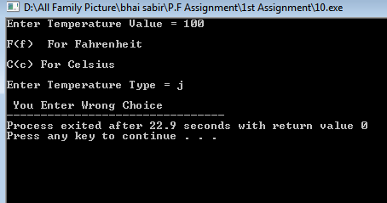

**Output console:2**

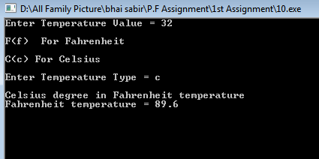

**Output console:1**

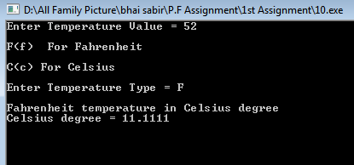

**11. Write a C++ program to input basic salary of an employee and calculate its Gross salary**

**according to following:**

**Basic Salary <=10000: HRA = 20%, DA = 80%**

**Basic Salary <= 20000: HRA = 25%, DA = 90%**

**Basic Salary > 20000: HRA = 30%, DA = 95%**

**Program:**

**#include<iostream>**

**#include<conio.h>**

**using namespace std;**

**int main ()**

**{**

**float BS, GS;**

**cout<<"Enter Your Basic Salary = ";**

**cin>>BS;**

**if (BS<=10000)**

**{**

**GS=BS+ ((20.0/100.0) *BS) + ((80.0/100.0) *BS);**

**cout<<endl<<endl<<"*************************************"<<endl;**

**cout<<"Gross Salary = "<<GS<<endl;**

**cout<<"*************************************"<<endl;**

**}**

**else if (BS<=20000)**

**{**

**GS=BS+ ((25.0/100.0) *BS) + ((90.0/100.0) *BS);**

**cout<<endl<<endl<<"************************************"<<endl;**

**cout<<"Gross Salary = "<<GS<<endl;**

**cout<<"*************************************"<<endl;**

**}**

**else**

**{**

**GS=BS+ ((30.0/100.0) *BS) + ((95.0/100.0) *BS);**

**cout<<endl<<endl<<"*************************************"<<endl;**

**cout<<"Gross Salary = "<<GS<<endl;**

**cout<<"*************************************"<<endl;**

**}**

**getch ();**

**return 0;**

**}**

**Output console:2**

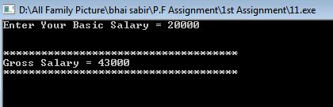

**Output console:1**

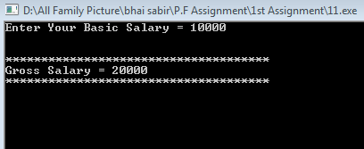

**Output console:3**

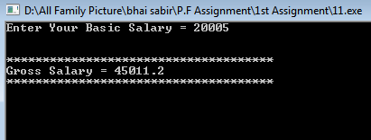

**12. Write a C++ program to input electricity unit charges and calculate total electricity bill**

**according to the given condition:**

**For first 50 units Rs. 0.50/unit**

**For next 100 units Rs. 0.75/unit**

**For next 100 units Rs. 1.20/unit**

**For unit above 250 Rs. 1.50/unit**

**An additional surcharge of 20% is added to the bill**

**Program:**

**Output console:1**

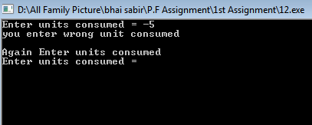

**#include<iostream>**

**#include<conio.h>**

**using namespace std;**

**int main ()**

**{**

**float u, b=0, total;**

**again:**

**cout<<"Enter units consumed = ";**

**cin>>u;**

**if(u<0)**

**{**

**cout<<"you enter wrong unit consumed"<<endl;**

**cout<<endl<<"Again Enter units consumed"<<endl;**

**goto again;**

**}**

**if(u>=50)**

**{**

**b=b+50*0.50;**

**}**

**u=u-50;**

**if(u>=100)**

**{**

**Output console:2**

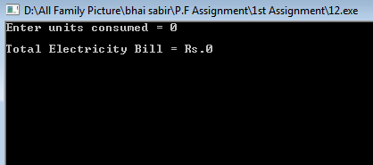

**b=b+100*0.75;**

**}**

**u=u-100;**

**if(u>=100)**

**{**

**b=b+100*1.20;**

**}**

**u=u-100;**

**if(u>=1)**

**{**

**b=b+u*1.50;**

**}**

**total=b+(20.0/100.0) *b;**

**cout<<endl<<"Total Electricity Bill = Rs."<<total;**

**getch ();**

**return 0;**

**}**

**Output console:4**

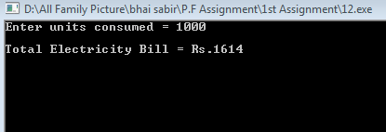

**Output console:3**

